Activity Sheet in Science 9
Name: ______________________________ Grade Level and Section: ________
School: ______________________________ Date: _______________________
Teacher: ____________________________ Score: _______________________

- Title: The Solar System
Learning Competency:
1. Identify the major components that comprise the solar system,
2. Describe the theories on the origin of the solar system,
3. Identify the basic features of the various planets in the solar system.

- Instructions: This activity sheet focuses on comparing planets of the solar
system—inner planets. Read the directions carefully and answer what is asked.

- Activities:

Guide:
The solar system is made up of planets revolving around the sun. These planets are categorized in to two - the inner planets and outer planets. On this activity sheet, you will apply what you have learn about inner and outer planets and their characteristics. The inner or terrestrial planets are Mercury, Venus, Earth and Mars, while the gas and ice giants the mercury.

The second classification of planets in the solar system is called the outer or Jovian planets. These planets are Jupiter, Saturn, Uranus and Neptune. There are many things you can discover about these planets while doing these activities.

Study the information about the inner planets below.
Planet | Name | Distance from the Sun | Diameter  Size | Temperature | Period of Revolution  (Length of Year) | Other Characteristics
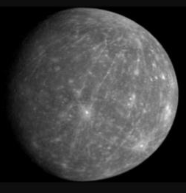 | Mercury | 58 million km. (36 million miles) | 4,879 km.  (3,032 miles) | 173 to 427 degrees Celsius | 87.97 Earth days | It has no moon.  It is a rocky planet.
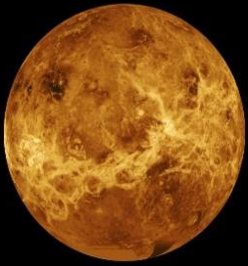 | Venus | 108 million km. (67 million miles) | 12, 104 km.  (7, 521 miles) | 462 degrees Celsius | 225 days | It has no moon.  It is known as morning star or evening star because it is brighter than any other object in the sky. The Twin planet of the Earth.
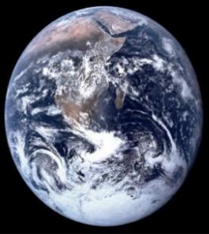 | Earth | 150 million km. (93 million miles) | 12, 760 km. (7,926 miles) | 14  Celsius | 365 ¼ days | It has one moon.  It is the only world known to harbor life.
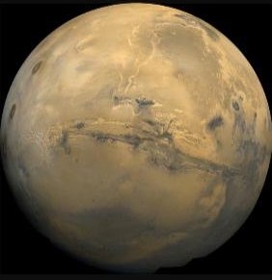 | Mars | 228 million km. (142 million miles) | 6,787 km. (4,217 miles) | -153 to  +20 degrees Celsius | 687 Earth days | It has two small moons.  It is known as Red Planet because iron minerals in the Martian soil oxide, or rust causing the soil to look red.

(Atkinson, 2015)

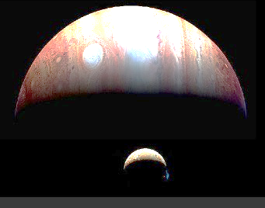

Jupiter
Jupiter is a large planet having a diameter of 428, 400 km. or 88, 730 miles. it's the fifth planet from the sun, at a distance of about 778 million km. or 484 million miles. It's the fastest rotating planet for it takes only 9.8 Earth hours every day. It takes about 11.9 Earth years to travel round the sun. it's composed of hydrogen and helium and other gases. Its temperature is -148 Celsius. The large red spot you'll see could be a storm. It has 67 moons. (Atkinson, 2015)
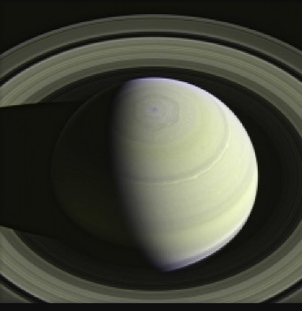

Saturn
Saturn is the second largest planet with a diameter of 120, 500 km (74, 900 miles). It's about 1.4 billion km. (886 million miles) off from the sun. It takes 29.5 Earth years to complete its revolution and 10.7 Earth hours for its rotation. Its temperature is about -178 Celsius. Its atmosphere is created of hydrogen and helium. It 53 moons. Saturn is understood due to its 7 rings with several gaps and divisions between them (Atkinson, 2015).
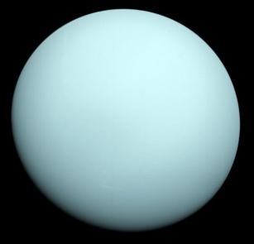

Uranus
Uranus is about 2.9 billion km. (1.8 billion miles) away from the sun, and its diameter is about 51, 120 km. (31,763 miles). It takes 84 Earth years to finish its revolution around the sun and 18 Earth hours rotation on its axis. It’s the coldest planet in our solar system with a temperature of -216 Celsius. The sun never rises nor sets in this planet. Uranus has 27 moons. It has faint rings; the inner rings are narrow and dark and the outer rings are bright (Atkinson, 2015).

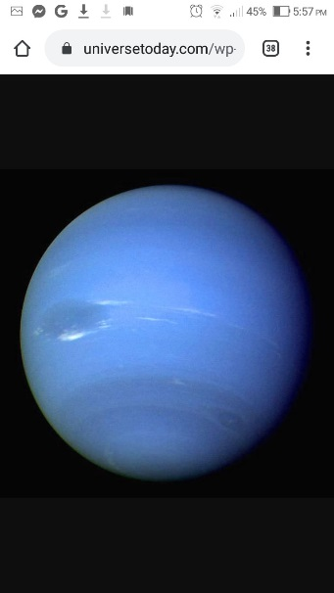

Neptune

Neptune is that the eight and farthest planet from the sun, at a distance of about 4.5 billion km. (2.8 billion miles). Its diameter is about 49, 530 km. (30, 775 miles). It takes 165 Earth years to end its revolution and 16 hours for its rotation. Its temperature is -214 Celsius. It has 13 moons. It is classified as ice giant. It has six rings. Its atmosphere is made from hydrogen, helium and methane (Atkinson, 2015).

Activity 1. Name and color it.
Directions: Identify the sequence of planets in the solar system and color them based on their characteristics.
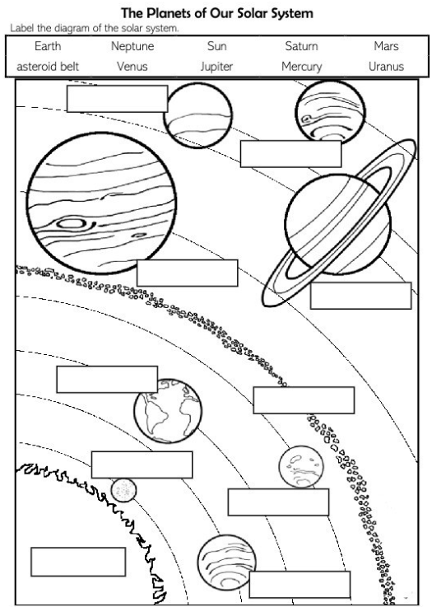

Activity 2. Fill me
Directions: Fill in the column of each planet that describes its characteristics. Choose your answer from the box below.

8 Planets in the Solar System
Mercury | Venus | Earth | Mars | Jupiter | Saturn | Uranus | Neptune

Characteristics of Terrestrial Planets
only planet that supports life has 2 moons
red planet the hottest planet
morning star or evening star the smallest planet
nearest planet to the sun revolves 365 ¼ days around the sun
has 1 moon rocky planet and has no moon
Rotating sideways the blue planet
The great RED SPOT the ringed planet
Lowest density planet methane-riched atmosphere
Hi-speed winds tiltet 98 degress

Activity 3. Complete Me
Directions: Complete the chart by filling out the table with the information about the outer planets.
Name of Planet | Distance from the Sun | Diameter | Temperature | Period of Revolution | Number of Moons | Other Characteristics
Jupiter | 778 million km. |  |  | 11.9 Earth years
Saturn |  | 120, 500 km. |  |  | 53 moons
Uranus | 2.9 billion km. |  | -216 Celcius
Neptune |  | 49, 530 km.

Activity 4
A. From the Distance
Directions: Arrange the inner planets according to its distance from the sun. Draw it on the solar system model below.
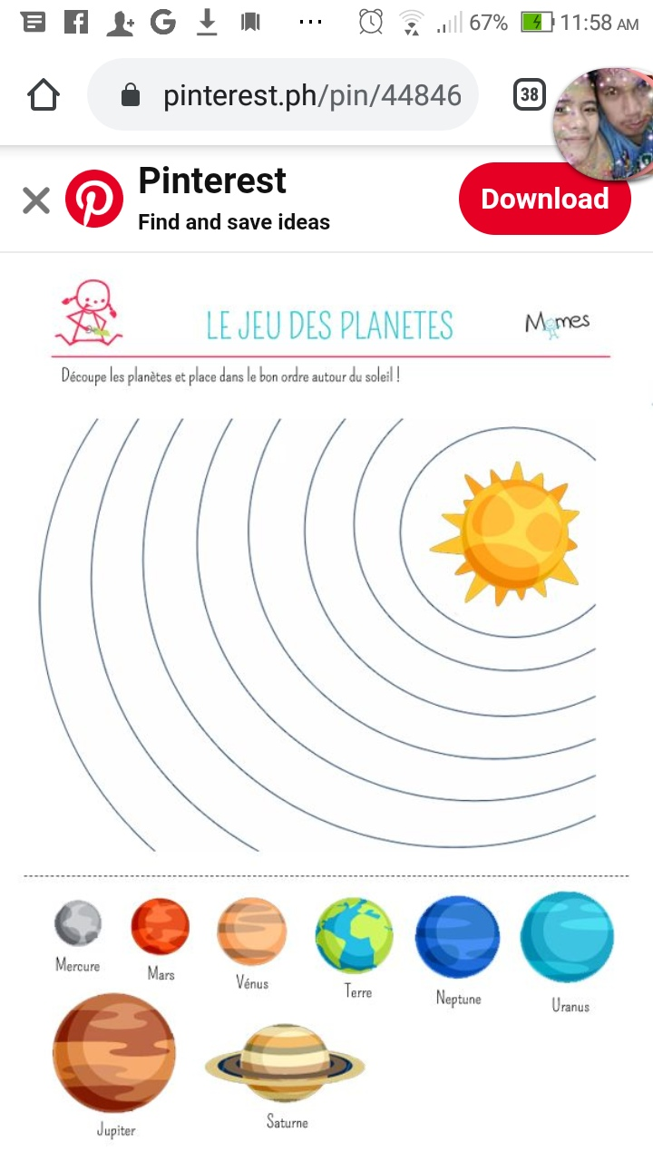
Earth
Mars
Mercury
Venus

(Pinterest)

B. Am I Big or Small?
Directions: Arrange the inner planets according to its size from smallest to biggest.
Number it from 1-4. Put your answer on Column C.
Column A | Column B | Column C
Planet | Size | (Your Answer)
Earth | 12, 760 km.
Mars | 6, 787 km.
Mercury | 4, 879 km.
Venus | 12, 104 km.

C. Number Me
Directions: Arrange the inner planets according to its temperature.
Number it from 1 to 4.
_____ Mercury ________ Earth
______ Venus ________ Mars
Activity 5
Directions: Read the questions below. Encircle the letter of the correct answer.
- Which inner planet is closest to the sun?
- Earth B. Mars C. Mercury D. Venus
- What is the distance from Venus to the sun?
- 58 million km. B. 108 million km C. 150 million km D.228 million km
- Which planet is called “Red Planet”?
- Earth B. Mars C. Mercury D. Venus
- Which planet where people can live?
- Earth B. Mars C. Mercury D. Venus
- Which inner planet is the hottest?
- Earth B. Mars C. Mercury D. Venus
- What is the diameter of the Earth?
- 4, 879 km. B. 12, 104 km. C. 12, 760 km. D. 6, 787 km.
- How many moons does Earth have?
- 1 B. 2 C. 3 D. 4
- What is another name for the inner planets?
- Extraterrestrial Planets C. Gas Giants
- Gas Dwarfs D. Terrestrial Planets
- How long does the Earth takes to revolve completely around the sun?
- 89.97 days B. 225 days C. 365 ¼ days D. 687 days
- Why is Venus the hottest planet?
- It spins the fastest. C. It has the most internal heat.
- It is closest to the sun. D. It has a powerful greenhouse effect.
11. Which outer planet is the biggest?
A. Jupiter B. Neptune C. Saturn D. Uranus
12. What is the distance from Jupiter to the sun?
A. 778 million km. B. 1.4 billion km C. 2.9 billion km D. 4.5 billion km
13. Which planet is known of its “Great Red Spot”?
A. Jupiter B. Neptune C. Saturn D. Uranus
14. Which planet is most famous because of its rings?
A. Jupiter B. Neptune C. Saturn D. Uranus
15. Which outer planet is the coldest?
A. Jupiter B. Neptune C. Saturn D. Uranus
16. What is the diameter of the Neptune?
A. 428,400 km. B. 120,500 km. C. 51,120 km. D. 49,530 km.
17. How many moons does Uranus have?
A. 13 B. 27 C. 53 D. 67
18. How long does the Neptune takes to revolve completely around the sun?
- 11.9 years B. 29.5 years C. 84 years D. 165 years
- Which is NOT an outer planet?
- Jupiter B. Saturn C. Triton D. Uranus
- Which statement is TRUE about the outer planets?
- The outer planets do not have many moons.
- Saturn is the only outer planet that has rings.
- The outer planets are all very warm and have volcanoes.
- The atmosphere of the outer planets is made of thick and swirling gases.

